**TWO BIT HALF SUBTRACTOR**

**EXP.NO: 22**

**AIM:**To design and implement the two bit half subtractor using Logisim simulator.

**PROCEDURE:**

1)      Pick and place the necessary gates.

2)      Insert 2 inputs into the canvas.

3)      Connect the inputs to the OR gate, AND gate and NOT gate.

4)      Insert 2 outputs into the canvas.

5)      Make the connections using the connecting wires.

6)      Verify the truth table.

**TRUTH TABLE:**  
  
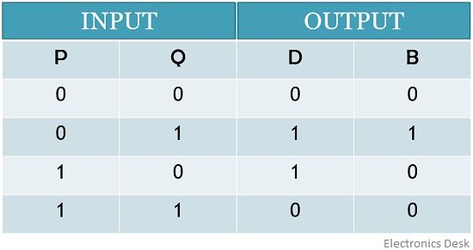  
  
Diff=A'B+AB'  
  
Borrow = A'B 

**OUTPUT:**

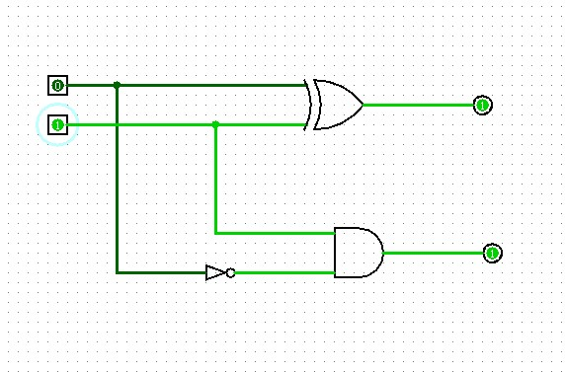  
  
  
  
**RESULT:**

Thus 2-bit half subtractor has been designed and implemented successfully using logisim simulator.